Lab 3

Part I: Linux
- Create an HTML file on your computer called “index.html”
- Open the index.html file with a text editor, like Notepad, and type the following line:
“Hello World from <your name>”
- Log into the AWS Console with your IAM user.
- Search for “S3”, then open it.
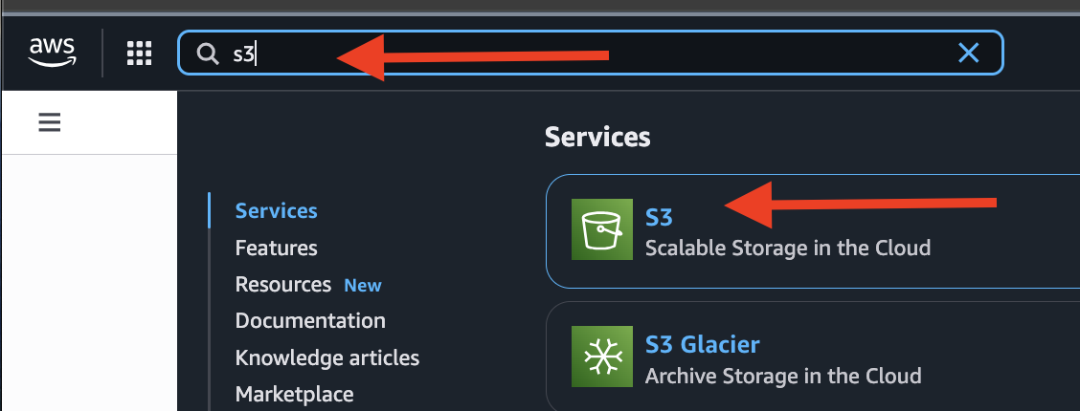
- Click orange “Create bucket” button.
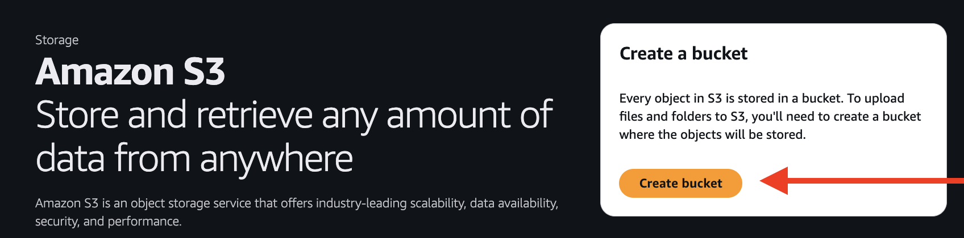
- Bucket type go with “General purpose” (should be default)
- The bucket name should be in all lower-case letters.
Note: Bucket name must be unique and must not contain spaces or uppercase letters
Try something includes your student # may be easier to get it unique.
- Make sure the Region matches your default region for your root AWS account.
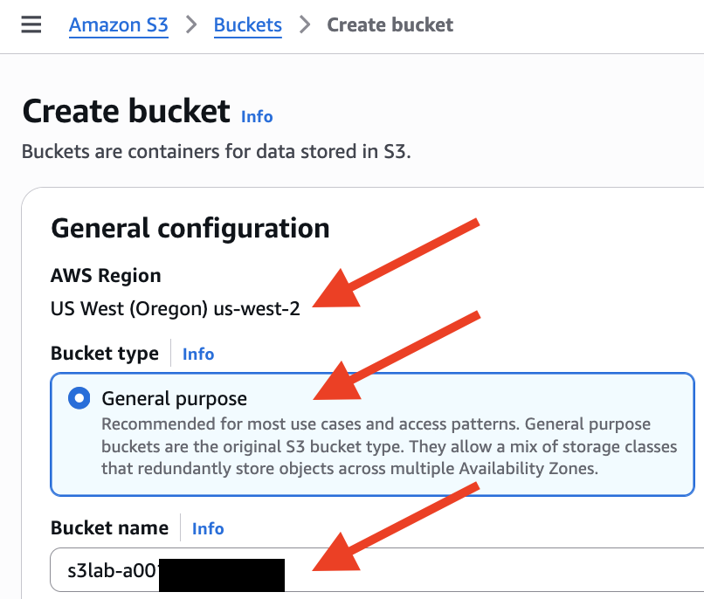
- Go to the bottom of the web page, click “Create bucket”.
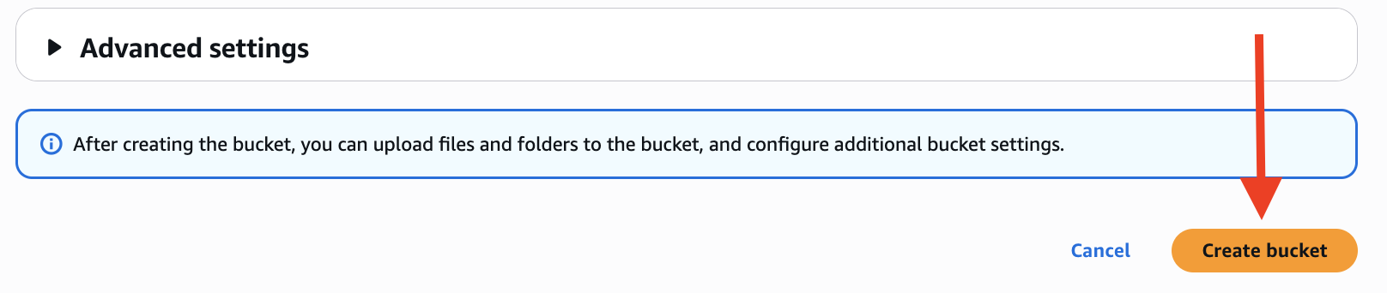
- Click the bucket name, to open the bucket main page.
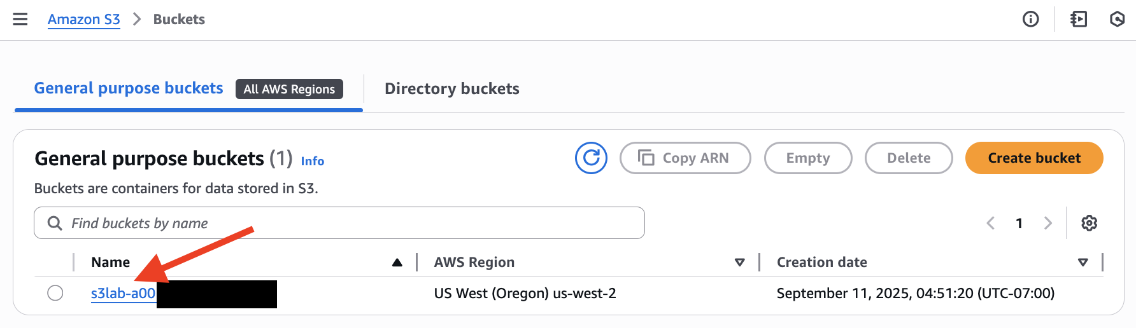
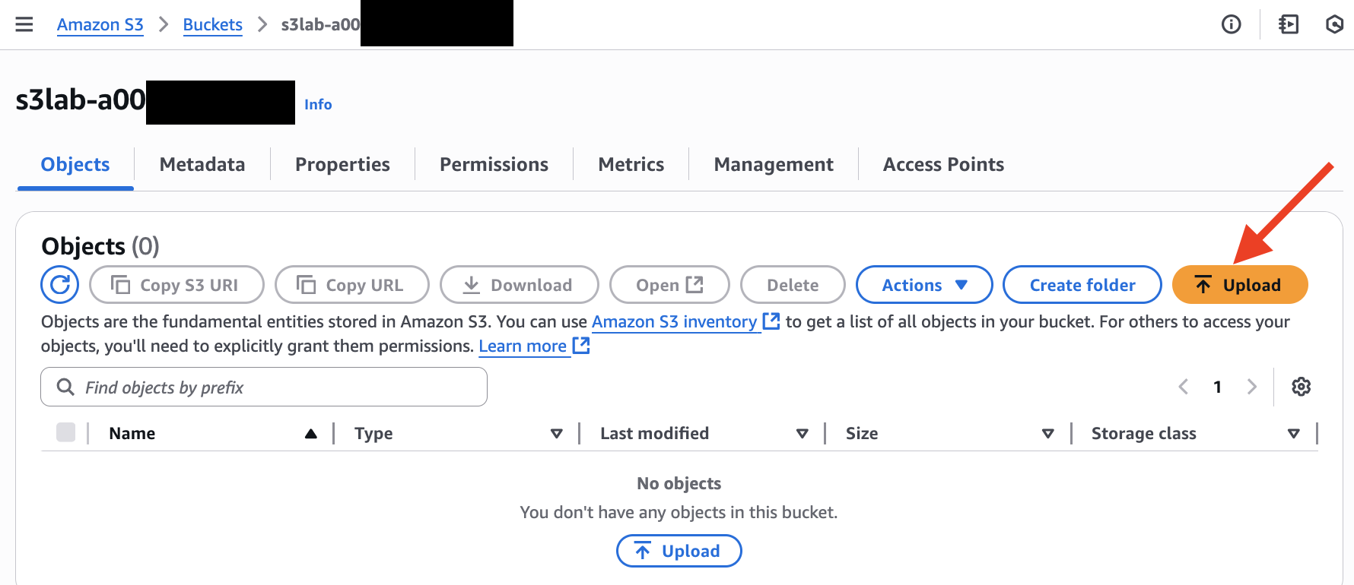
- Upload the index.html file (you created on step #1) to this bucket.
  - Use “Upload” button.
  - “Add files” and then choose your index.html file. Or drag-and-drop your file.
  - “Upload”
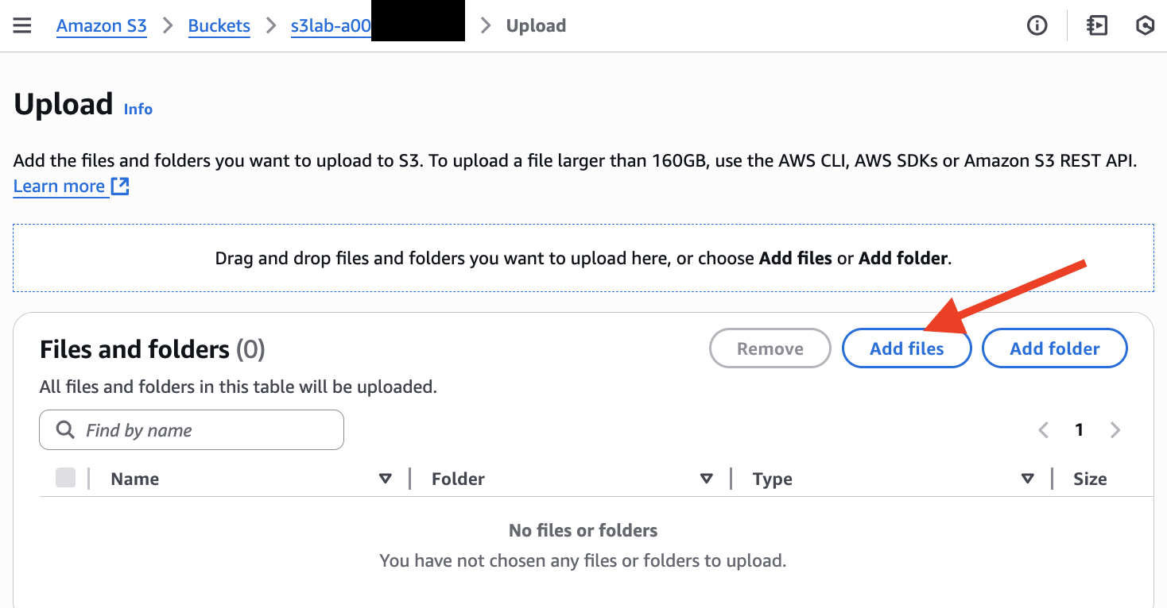
- Wait till the uploading is done, copy down the S3 URI for later reference.
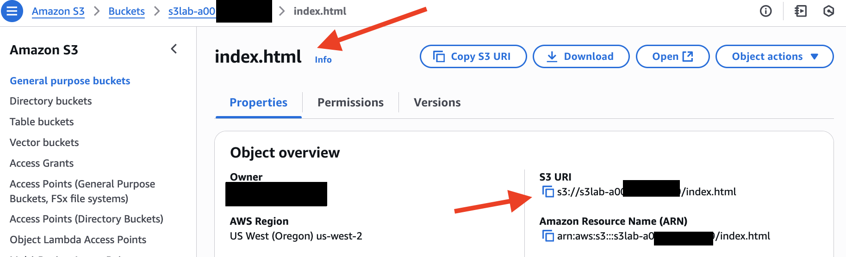
Create an IAM Role to allow access to S3 buckets.
- From your account name in the top right corner of the AWS console, in the dropdown list, select “Security credentials”.
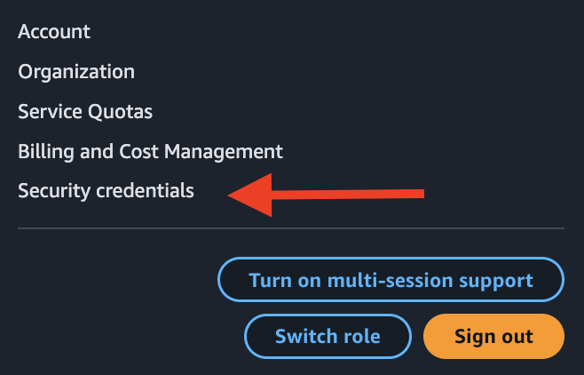
- On the left-hand side menu, select “Roles”.
- Click “Create role” button.
- In Step 1: Select trusted entity choose “AWS Service”; in Use case section select “EC2”
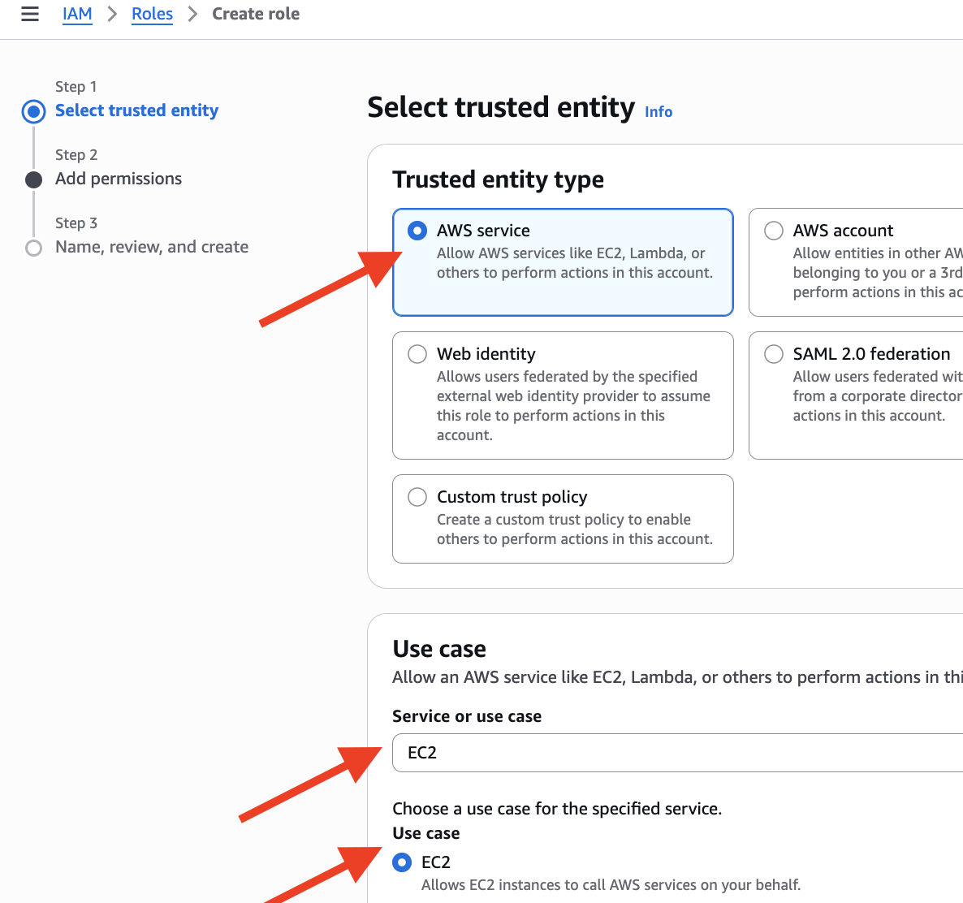
- Click “Next”.

- Search for “S3”, then select the policy “AmazonS3FullAccess”.

- Search for “EC2”, then select the policy “AmazonEC2FullAccess”.
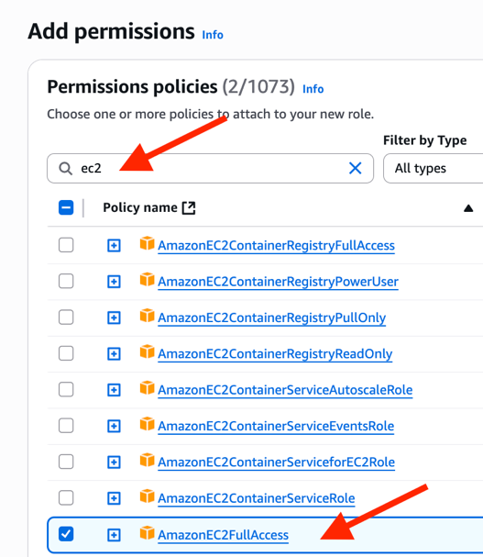
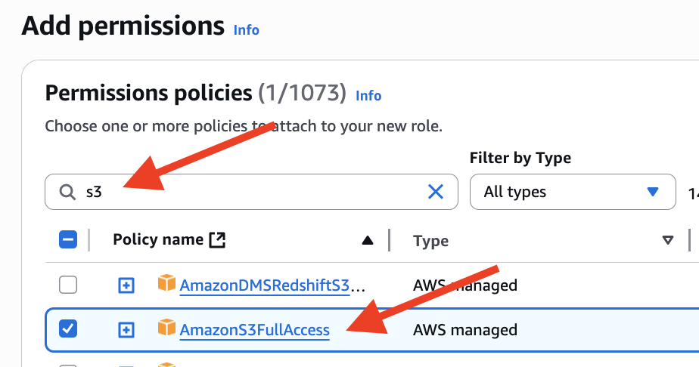

- Click “Next” button
- Type in a role name, such as S3-EC2-Access.
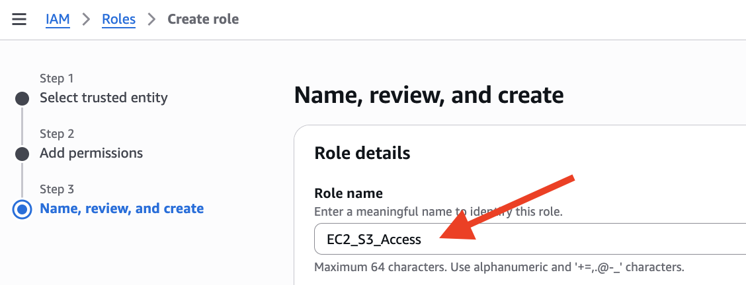
- Review (and confirm) both of two policies are shown under “Step 2: Add permissions”
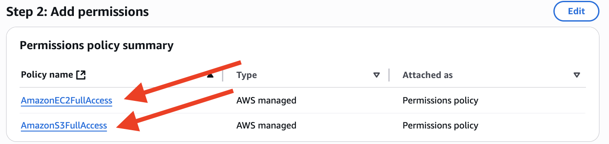
- Click “Create role” button at the bottom of the page.
Launch webserver using Linux EC2 instance
- Navigate to the EC2 area of AWS.
- Linux EC2 instance
  - Your choice of OS with “Free tier eligible” Amazon Linux AMI. (default is OK)
  - Instance type: double check the default is “t3.micro” with “Free tier eligible”.
  - Select your own Key pair. (could be the same key pair in previous labs)
  - Create security group with “Allow SSH traffic” (default) and add “Allow HTTP traffic from the internet”
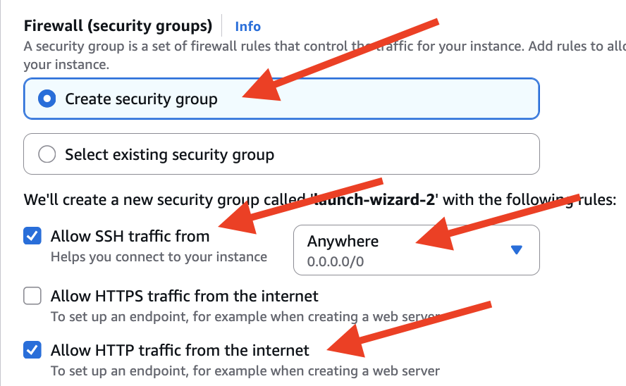
  - Expand Advanced details section; for IAM instance profile choose our new IAM role to “EC2-S3-Access” from the drop-down list.
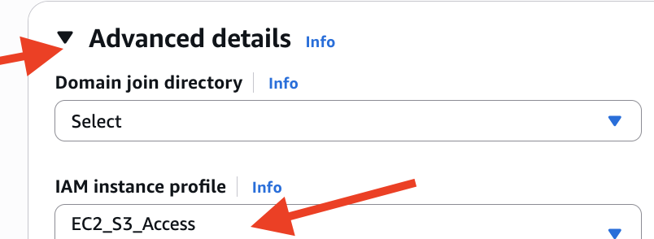

  - Swipe down “Advanced details” section, find “User data - optional” section
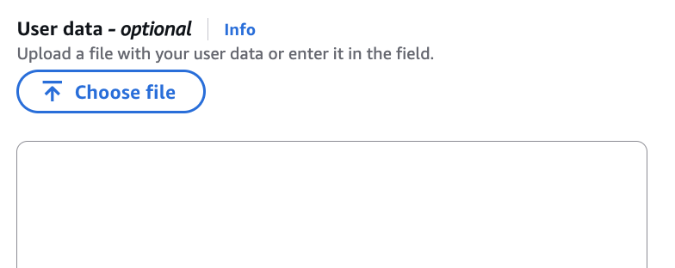
  - Copy & paste the following bash (shell) script, into the User data section
#!/bin/bash
yum install httpd -y
yum update -y
aws s3 cp s3://s3lab-a0xxxxxxxx/index.html /var/www/html/
service httpd start
chkconfig httpd on

  - Make sure to replace the highlighted part with your own S3 URI (Hint: Step 12)
  - What does user data do? This is the script to be executed when EC2 turning on.
  - “Launch instance”.
- Once the instance is up and running, copy the Public IP address to the browser on your workstation or laptop.
- When you see your Hello World page in browser, confirm you see your own page.
[Hint: some browsers automatically add https:// prefix in the url. If so, change to http:// ]
- Go to your instructor to get sign-off.
Note: If you got here outside of class time, “stop” your instance. Don’t keep it “running”
You may “restart” it when you are back in class to get your in-person sign-off.
- After receiving your sign-off, make sure to terminate your EC2 instance.

Part II: Windows
Bootstrap a Windows instance.
- Launch an EC2 with Microsoft Windows Server 2019 Base – Free tier eligible.
  - Select your key pair
  - When setting up the Security Group, make sure add “Allow HTTP traffic… ”
Also need RDP protocol (should be default on)
  - Do NOT use the IAM role from Part I, above. Leave the role as None.
  - In the Advanced details area, enter the following code:
<powershell>Install-WindowsFeature Web-Server -IncludeManagementTools -IncludeAllSubFeature</powershell>
  - What does this code do?
  - Launch it.
- After the instance has passed the Status Checks, RDP into the instance.
- Launch the Server Manager Dashboard.
- On the left, you should see that IIS has been installed. (if not, just wait for a bit)
- Minimize the Server Manager screen.
- From a web browser on your laptop, enter the Public IP address of the instance. Is IIS running?
- Go back to the Windows instance.
- Open the Windows File Explorer and navigate to the directory C:\inetpub\wwwroot.
- Make a copy of the iisstart.htm file.
- Open the iisstart.htm file with a text editor, like Notepad.
- Remove the <style> tag and all its contents, up through </style>.
- Go the tag <div id=”container”>

- Enter the following code after that tag line, replacing what is currently there:
<a href="http://169.254.169.254/latest/meta-data/">Instance Metadata</a>
<a href="http://169.254.169.254/latest/meta-data/hostname">Instance Hostname</a>
<a href="http://169.254.169.254/latest/meta-data/placement/availability-zone">Instance Availability Zone</a>
<a href="http://169.254.169.254/latest/user-data">Instance Userdata</a>
- Launch Internet Explorer from within the instance.
- Enter the URL “127.0.0.1”.
- Click on the hyperlinks.
- Go to your instructor to get sign-off.
Note: If you got here outside of class time, “stop” your instance. Don’t keep it “running”
You may “restart” it when you are back in class to get your in-person sign-off.

Teardown checklist
- Terminate all your EC2 instances.
- Important: Delete the S3 bucket containing the index.html file.
Hint: To delete an S3 bucket, you need to empty it first.

